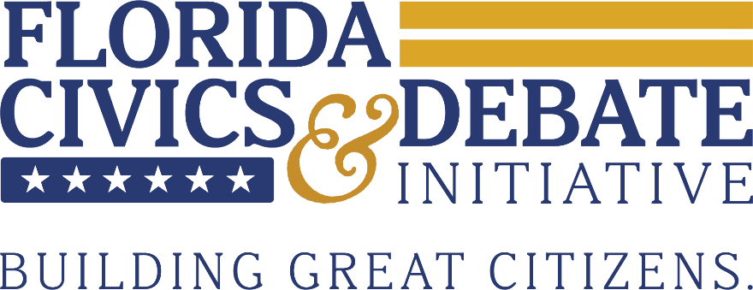
Florida Civics & Debate Initiative State Championship
Finals Legislation
Students shall assume the role of the Florida legislature for the final round of the State Championship.
Table of Contents
101. A Bill to Abolish Smoking Products in Public Areas
102. A Bill to Reform the Criminal Justice System in Florida
103. A Bill for A Brighter Future
104. A Joint Resolution Proposing an Amendment to Article VI of the State Constitution to
Establish Open Primary Elections

101. A Bill to Abolish Smoking Products in Public Areas
BE IT ENACTED BY THE LEGISLATURE OF THE STATE OF FLORIDA THAT:
Section 1. All smoking products such as combusted products, heat-not-burn products and electronic nicotine delivery systems are hereby banned from all public spaces in Florida.
Section 2. Combusted products are defined as any tobacco or similar products that produce smoke through the burning of tobacco or other substance, including cigarettes, cigars, pipes and hookah. Heat-not-burn products are defined as electronic devices that heat a processed tobacco or similar substance to a temperature sufficient to release nicotine-containing aerosol or vapor, without causing combustion of the material. Electronic nicotine delivery systems are defined as battery-powered or electronically powered devices that deliver nicotine, flavorings or other substances to the user in the form of an aerosol or vapor, including e-cigarettes, vape pens, electronic cigars and similar devices.
Section 3. The Florida Department of Health in conjunction with the Florida Department of Business and Professional Regulation will oversee the implementation of this legislation.
- Violation of this act will result in a fine of up to $500 per violation.
SECTION 4. This legislation will take effect on January 1, 2027.
SECTION 5. All laws in conflict with this legislation are hereby declared null and void.
Introduced for Legislative Debate by Evan Convery from Pinecrest Academy Middle.

102. A Bill Reform the Criminal Justice System

BE IT ENACTED BY THE LEGISLATURE OF THE STATE OF FLORIDA THAT:
Section 1. The following reforms shall be made to the criminal justice system in Florida:
- No individual charged with a criminal offense in the state of Florida shall be required to post cash bail or any other form of monetary requirement as a condition of pretrial release. Release decisions shall be based solely on risk assessment, public safety, flight risk and the nature of the alleged offense.
- Plea bargaining is hereby prohibited in all criminal cases in the state of Florida. All cases shall proceed to trial unless the defendant is acquitted, charges are dismissed by the court or the prosecutor formally withdraws charges.
Section 2. Cash bail is defined as a sum of money required for the pretrial release of a defendant, including deposits, bonds or surety payments. Plea bargaining is defined as any agreement in which a defendant agrees to plead guilty or no contest in exchange for reduced charges, sentence or other prosecutorial concessions.
Section 3. The Florida Department of Corrections, in conjunction with the Florida Office of the State Courts Administrator, are responsible for implementing this legislation.
SECTION 4. This legislation will take effect on January 1, 2027.
SECTION 5. All laws in conflict with this legislation are hereby declared null and void.
Introduced for Legislative Debate by FCDI Staff.
103. A Bill for A Brighter Future

BE IT ENACTED BY THE LEGISLATURE OF THE STATE OF FLORIDA THAT:
Section 1. The Florida Bright Futures Scholarship Program shall limit scholarship eligibility to undergraduate students pursuing degrees in designated workforce-driven fields. Students enrolled in non-designated majors shall not be eligible for scholarship funding and Bright Futures eligibility shall be revoked upon a student’s transfer into a non-eligible major. Majors in the following fields shall be eligible for the Bright Futures Scholarship:
- Science, technology, engineering and mathematics (STEM), including computer science, engineering, biology, chemistry, physics, mathematics, information technology and cybersecurity;
- Healthcare and medical fields, including nursing, pre-medical studies, public health, pharmacy and allied health professions;
- Construction and skilled trades;
- Education, including elementary education, secondary education and exceptional student education;
- Public safety and emergency services, including criminal justice, firefighting, emergency medical services and law enforcement;
- Business and finance fields, including accounting, finance and business analytics;
- Agriculture and natural resources, including agricultural science, agribusiness, environmental management and marine science;
- Transportation and logistics, including aviation management, maritime studies and logistics and distribution management;
- Public administration and related fields, including urban planning, public policy and emergency management.
Section 2. Undergraduate students are defined as individuals enrolled in a postsecondary institution pursuing an associate or bachelor’s degree.
Section 3. The Florida Department of Education shall oversee enforcement of this legislation.
- The Department of Education will publish a list of eligible majors pursuant with Section 1.
- Postsecondary institutions will verify that scholarship recipients are enrolled in eligible majors prior to the disbursement of funds each semester.
- Students enrolled in undergraduate studies prior to the effective date of this legislation will not be affected.
SECTION 4. This legislation will take effect in the 2027-2028 academic year.
SECTION 5. All laws in conflict with this legislation are hereby declared null and void.
Introduced for Legislative Debate by FCDI Staff.

104. A Joint Resolution Proposing an Amendment to Article VI of the State Constitution to Establish Open Primary Elections
BE IT RESOLVED BY THE LEGISLATURE OF THE STATE OF FLORIDA THAT:
The following amendment to Article VI of the State Constitution is agreed to and shall be submitted to the electors of this state for approval or rejection at the next general election or at an earlier special election specifically authorized by law for that purpose:
ARTICLE VI:
SUFFRAGE AND ELECTIONS
SECTION 5. Primary, general and special elections.—
Any registered voter may participate in the primary election of any political party, regardless of the voter’s party affiliation. The candidate receiving the highest number of votes in each party’s primary shall advance to the general election. If only two candidates qualify for an office, no primary election shall be held, and the winner shall be determined in the general election.
BE IT FURTHER RESOLVED that the following statement be placed on the ballot:
CONSTITUTIONAL AMENDMENT
ARTICLE VI, SECTION 5
OPEN PRIMARIES FOR FLORIDA STATE ELECTIONS. - Allows all registered voters to vote in the primary election of any political party, regardless of their party affiliation. The candidate receiving the most votes in each party’s primary advance to the general election. If only two candidates qualify for an office, no primary is held, and the winner is determined in the general election.
Introduced for Legislative Debate by FCDI Staff.

